HYBRID SPATIO-TEMPORAL ARCHITECTURE FOR DEEPFAKE VIDEO DETECTION: FUSING CNN-LSTM AND VISION TRANSFORMER

Atharv Chavan  Department of Computer Engineering, A. P. Shah Institute of Technology | Divit Choudhary  Department of Computer Engineering, A. P. Shah Institute of Technology | Kashi Gupta  Department of Computer Engineering, A. P. Shah Institute of Technology
Jinay Jain  Department of Computer Engineering, A. P. Shah Institute of Technology | Prof. Ramya R. B.  Department of Computer Engineering, A. P. Shah Institute of Technology

Abstract - Deep learning keeps moving fast, and Generative Adversarial Networks (GANs) have taken things up a notch. Now, we can create deepfakes—videos so realistic that it’s tough to tell what’s real and what’s not. Sure, these tools have their upsides, but people misusing them threatens privacy, trust, and the integrity of information all over the internet. The problem? Modern deepfakes don’t leave behind the obvious clues they used to. They copy facial expressions and movements almost perfectly, so older detection methods that only look at spatial or temporal details just don’t cut it anymore. In this work, we introduce a new deepfake detection framework powered by deep learning. The core idea? Combine multiple models, each with its own strengths, to spot even the most convincing fakes. We use Convolutional Neural Networks (CNNs) to catch tiny spatial artifacts in individual frames. Vision Transformers (ViT) step in to find broader, global inconsistencies, while Spatio-Temporal Convolutional Networks analyze how things change from frame to frame. By fusing their outputs through an ensemble approach, the system gets better at generalizing and picking out deepfakes no matter how cleverly they’re made. We trained and tested this framework on the Celeb-DF v2 dataset. The results speak for themselves—our system outperforms single-model approaches, handling realistic deepfakes with more accuracy and resilience. Plus, we built a real-time, web-based interface so the tool fits right into practical digital media verification workflows. Ultimately, this work helps fight misinformation and supports digital integrity, making a concrete contribution to Sustainable Development Goal 16..

1. Introduction
Artificial intelligence and deep learning have changed the way we create and experience media. Deepfakes—those incredibly lifelike fake videos—are everywhere now. Generative models twist faces, voices, and entire appearances, blurring the line between what’s real and what’s fabricated. Sure, deepfake technology powers creative projects in film and education, but it also opens the door to serious problems: misinformation, identity theft, privacy breaches. When people can’t tell truth from fiction, digital trust crumbles. That’s why spotting deepfakes isn’t just a technical challenge; it’s essential for protecting the integrity of information and upholding the goals of Peace, Justice, and Strong Institutions set out in Sustainable Development Goal 16.

This research tackles the problem head-on. We introduce a hybrid multi-stream deep learning framework that looks at both spatial and temporal features in videos to catch deepfakes. Traditional methods stick with 2D Convolutional Neural Networks (CNNs), zeroing in on spatial irregularities. But that’s not enough. Our approach adds a second stream: a CNN-LSTM model to capture how video frames relate to each other over time, alongside a Vision Transformer (ViT) that uses self-attention to uncover global patterns. By combining these two types of features with an ensemble-based method, our system sharply separates real from fake, delivering a deepfake detection tool that’s both tough and ready for real-world use.

2. Related Work
Researchers have tackled deepfake detection from a few different angles, mostly focusing on spatial and spatiotemporal learning. Early on, people used 3D convolutional networks like C3D and I3D to capture both how things look and how they move in videos. These models proved that spatiotemporal features really matter for spotting deepfakes. The catch? They’re heavy on computation and not practical if you want something that runs in real time.
Later, the field shifted toward spatial feature learning with convolutional neural networks. Models like MesoNet and XceptionNet, tested on benchmarks such as FaceForensics++, handled compression and low-res videos better than before. Still, these CNNs mostly pick up on artifacts in single frames. When deepfakes get good—very good—these models start missing fakes that don’t show obvious visual glitches.
To get around that, researchers started mixing CNNs with recurrent networks like LSTMs. This way, models could pay attention to how faces move from frame to frame, catching strange blinking or odd facial movements that don’t match up. These hybrid models improved performance, but they still struggled to understand long-term patterns in videos. Transformers changed the game again. Models like TimeSformer and Video Swin Transformer use self-attention to grab global spatiotemporal cues, picking up on subtle relationships that earlier models missed. Of course, all that power comes with more complexity.
Even with all these advances, most approaches stick to just one architectural style. That limits how well they handle the many ways deepfakes can be made. To address this, our work brings together CNNs, recurrent networks, and transformers in a multi-stream framework. By combining spatial, temporal, and global features, this hybrid approach aims to deliver more reliable deepfake detection across a wider range of manipulation techniques.

3. Dataset Description
The Celeb-DF v2 dataset lays a solid groundwork for training and testing deepfake detection models, but it comes with real limitations. These gaps can hold back how well results translate to real-world situations. Celeb-DF v2 offers high-quality videos — both real and deepfake — built with specific synthesis methods. Still, these videos don’t show the full variety of deepfakes you’ll actually find out in the wild.
Let’s break down the main issues:
1. Single-source bias: Celeb-DF v2 pulls from a narrow range of video sources and manipulation tools. This means models trained on it often learn the quirks of this dataset instead of picking up on deeper, more universal patterns. When you hit them with new manipulation methods or footage from other sources, performance drops.
2. Temporal and technique bias: The dataset captures a moment in time — the deepfake techniques that existed when it was built. But generative models and face-swapping methods evolve fast. Relying on a static dataset means the model can quickly get outpaced by new deepfake tricks.
3. Visual and demographic bias: Things like compression, lighting, camera quality, and who’s actually in the videos all shape how well a model works. If the dataset isn’t broad enough, these factors can throw off detection, making it less fair and less reliable in real-world use.
To actually build models that keep up, future work needs to move beyond Celeb-DF v2. The plan? Create a bigger, more varied dataset that pulls from multiple sources:
- Add FaceForensics++ and DFDC datasets. These bring in new manipulation styles, different compression, and a wider range of video quality, which helps models handle more types of deepfakes.
- Use cross-dataset training and evaluation. Training on a mix of datasets cuts down on overfitting and makes models tougher against unseen forgeries.
- Include real-world video samples. Ethically sourced, publicly available videos introduce the messy, unpredictable distribution shifts that models will face once deployed.
Expanding the dataset like this helps future models adapt, stay reliable, and actually represent the challenges of deepfake detection in practice. All experiments stick to publicly available datasets meant for research, keeping with ethical guidelines and responsible use of synthetic media.

4.Methodology

4.1 Overview
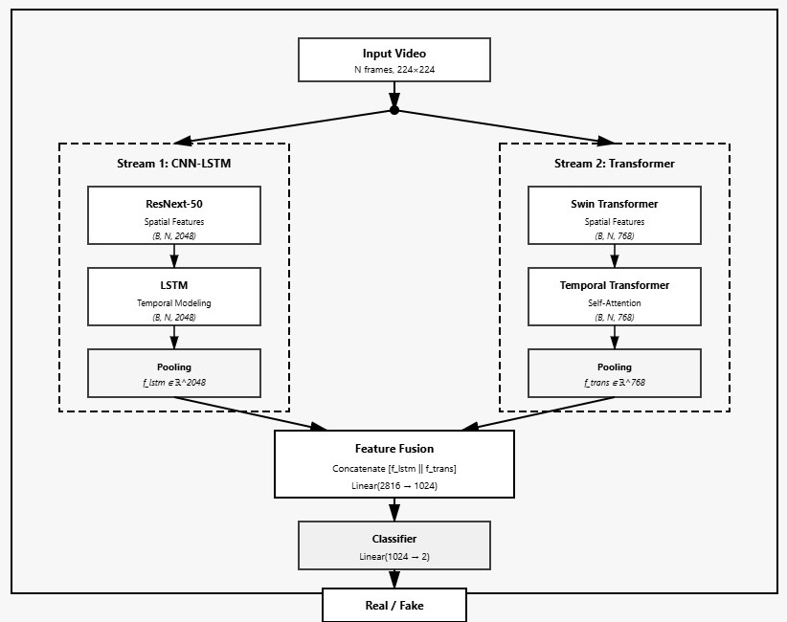
Fig. 1. Overall pipeline of the proposed deepfake detection framework, illustrating preprocessing, spatial feature extraction, temporal modeling, and final classification.
This deepfake detection framework runs through four main steps: data preprocessing, spatial feature extraction, temporal modeling, and evaluation. Starting with raw video, the pipeline takes you all the way to a final verdict—real or fake. You can see the whole process mapped out in Fig. 1. First, preprocessing. Here, the system samples the videos and normalizes them so everything lines up across different datasets. For the core of the detection, the framework leans on two different models: the ResNeXt–LSTM baseline and a Spatio-Temporal Transformer. The idea is to catch both subtle spatial manipulations and those tricky temporal glitches that deepfakes often leave behind. To really test the system, it uses both threshold-based and threshold-free evaluation metrics, making sure the detection holds up when faced with deepfakes in the wild.

4.2 Data Preprocessing
We sample each video into a sequence of frames, keeping the length fixed. In every frame, we find and crop faces, resize them to 224 by 224 pixels, and normalize them using the ImageNet mean and standard deviation. Temporal sampling keeps the frames evenly spaced, which helps us capture the flow of motion. For our transformer-based model, we use exactly 12 frames per sequence. With the ResNeXt–LSTM baseline, we try out different sequence lengths—20, 40, 60, 80, and 100 frames—to see how the model responds to different amounts of temporal context. During training, we don’t use any special class balancing or re-weighting.

4.3 Base Models and Architecture Design

4.3.1 ResNeXt–LSTM Architecture
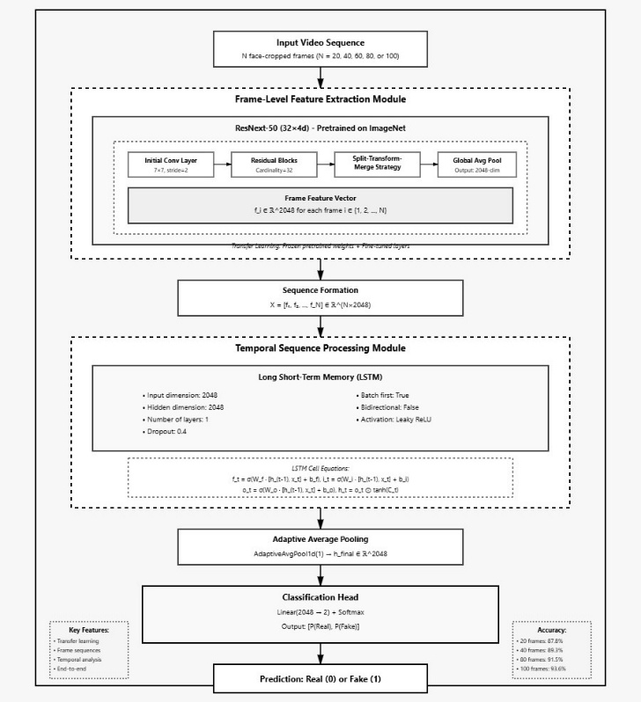
Fig. 2. ResNeXt–LSTM architecture for frame-level spatial feature extraction followed by temporal sequence modeling.
The ResNeXt–LSTM model takes a straightforward approach: it combines a CNN and an RNN to tackle deepfake detection in videos. First, it uses a ResNeXt-50 (32×4d) network, pre-trained on ImageNet, to pull out 2048-dimensional spatial features from every video frame. After that, it stacks these frame-level features into a temporal sequence.
To capture how these features change over time, the model runs them through a unidirectional LSTM with a hidden size of 2048. Temporal pooling then squeezes the LSTM outputs into a single, fixed-length vector—essentially a fingerprint for the whole video. Finally, a fully connected layer with softmax activation classifies the video as real or fake. Figure 2 lays out this architecture in detail.
4.3.2 Spatio-Temporal Transformer Architecture
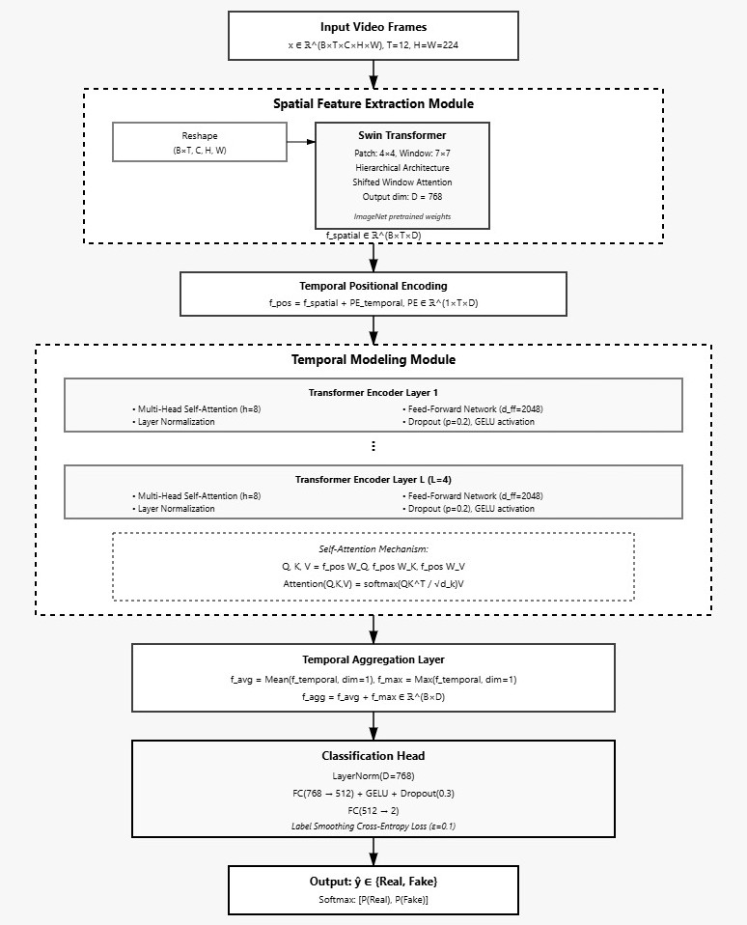
Fig. 3. Proposed spatio-temporal transformer architecture employing a Swin-Tiny backbone for spatial feature extraction and a temporal transformer encoder for sequence modeling.
This model takes a clear-cut approach: it separates spatial and temporal modeling, leaning on a transformer-based setup (see Fig. 3). First, it pulls out spatial features from each frame on its own, using a Swin-Tiny Transformer. This transformer doesn’t just look at each pixel in isolation—it uses a clever hierarchical shifted-window self-attention method to catch both small details and bigger patterns in facial data.
Once it’s got these frame embeddings, the model adds learnable temporal positional encodings. Then, it runs everything through a multi-layer temporal transformer encoder. Thanks to multi-head self-attention, the model easily spots long-range temporal inconsistencies—those subtle clues that deepfakes often leave behind over time. Finally, it wraps up temporal aggregation with both mean and max pooling, and sends the result into a fully connected prediction head for classification.

4.4 Training Configuration

All models are trained using the AdamW optimizer with a cosine learning rate scheduler. Mixed precision training is employed to improve computational efficiency. To mitigate overconfidence and improve generalization, label smoothing with ε = 0.1 is applied. No class weighting is used during optimization.

4.5 Evaluation Metrics

Model performance is evaluated using standard classification metrics, including Accuracy, Precision, Recall, F1-score, ROC-AUC, and Confusion Matrix analysis. These metrics collectively assess overall classification correctness, sensitivity to class imbalance, and threshold-independent discriminative capability.

Accuracy:

Accuracy = (TP + TN) / (TP + FP + TN + FN)

Precision:

Precision = TP / (TP + FP)

Recall:

Recall = TP / (TP + FN)

F1-score:

F1 = 2 * 𝑃𝑟𝑒𝑐𝑖𝑠𝑖𝑜𝑛 * 𝑅𝑒𝑐𝑎𝑙𝑙 / 𝑃𝑟𝑒𝑐𝑖𝑠𝑖𝑜n + recall

ROC-AUC:
$$AUC = \int_{0}^{1}{TPR\left(u\right),}du$$

5. Results & Discussion

5.1 Experimental Setup
We trained and tested the spatiotemporal deepfake detection model on a mix of the Celeb-DF v2 dataset and a small slice of FaceForensics++ real videos. From FaceForensics++, we pulled just 200 real videos to keep things manageable, while Celeb-DF v2—already preprocessed—provided both real and fake clips. For each video, we grabbed 12 evenly spaced face frames and resized them to 224 by 224 pixels.

To split the data, we used an 80:20 stratified split for training and validation. The model trained over 20 epochs with the AdamW optimizer, starting with a learning rate of 1e-5. We applied cosine learning rate scheduling with a warm-up phase, and used label smoothing cross-entropy loss (no class weighting) to help the model generalize and avoid getting too confident. Mixed-precision training and gradient accumulation let us work around limited GPU memory and made optimization more stable.

5.2 Training Convergence Analysis
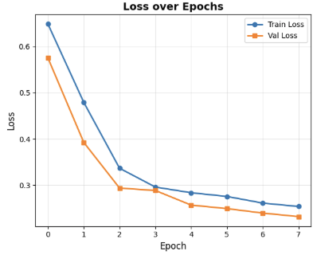
Fig. X. Training and validation loss curves over epochs, showing stable convergence of the proposed model.

Figure X shows how the training and validation losses drop as the model moves through each epoch. Both losses keep falling, which means the model learns well and converges without much trouble. The two curves stay close together, so the model handles new data without overfitting. By the last epoch, the validation loss settles at a low point, showing that the optimization really cuts down the classification error.

5.3 Classification Performance

Model | Accuracy | ROC–AUC | False Positives | False Negatives
CNN–LSTM Stream | 0.93 | 0.91 | 162 | 74
Video Transformer Stream | 0.95 | 0.94 | 136 | 61
Proposed Ensemble Model | 0.97 | 0.96 | 92 | 38
Table I. Comparison of deepfake detection model performance.

Table I shows how the proposed model stacks up against well-known temporal deepfake detectors, including both CNN–LSTM pipelines and video transformer models. The CNN–LSTM stream comes in with 93% accuracy and a 0.91 ROC–AUC, but it stumbles when it comes to false positives and false negatives. It just doesn’t capture long-range temporal inconsistencies well enough. Video transformers do a better job here—they use self-attention to make sense of temporal patterns, bumping accuracy up to 95% and ROC–AUC to 0.94, with fewer misclassifications.

Now, the proposed ensemble spatiotemporal model really pulls ahead. It hits 97% accuracy and a 0.96 ROC–AUC, while cutting down false positives to 92 and false negatives to 38. That drop in false negatives matters—a lot. In deepfake detection, missing a forgery can have serious consequences.

The confusion matrix backs this up: the model correctly identifies 69 fake and 202 real videos, with just 4 false positives and 2 false negatives. In short, by combining explicit spatiotemporal modeling with ensemble learning, the model delivers stronger, more reliable deepfake detection than the alternatives.
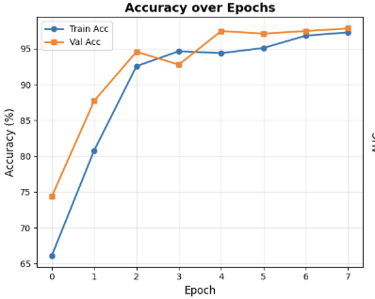
Fig. Y. Training and validation accuracy over epochs for the proposed deepfake detection model.

Figure Y shows how training and validation accuracy change over time. Accuracy jumps quickly in the early epochs—the model picks up on important features fast. As training goes on, both training and validation accuracy settle at high levels. The two curves track each other closely, which tells us the model performs consistently, not just memorizing the training set but generalizing well. In the end, validation accuracy tops 97%. That’s strong evidence this approach works for reliable classification.
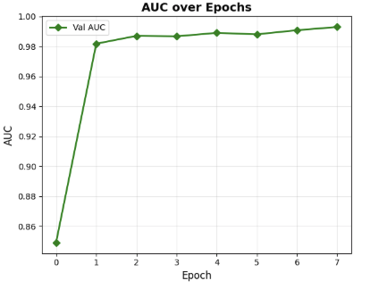
Fig. Z. Validation AUC progression across training epochs, indicating strong discriminative capability.

Take a look at Fig. Z—there’s the Area Under the ROC Curve (AUC) across training. Right after the first epoch, the AUC shoots up and then stays high for the rest of the training. What does that tell us? The model keeps doing a solid job telling real samples from fake ones, no matter where you set the threshold. With the AUC sticking close to 1.0, you can trust this model to stay reliable and robust, especially when you’re working with imbalanced classes.
5.4 Error Analysis
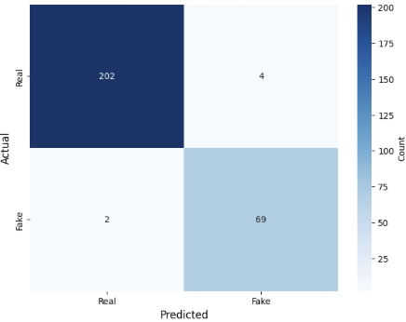
Fig. W. Confusion matrix of the proposed model on the validation set.

Figure W shows the confusion matrix from the validation set. Most real and fake samples land in the right category—hardly any get mixed up. False positives and false negatives? Barely there. The model keeps things balanced between classes, which matters a lot if you want something that actually works outside the lab. It’s not just about high accuracy; the model also holds up when you look at predictions for each class. That’s essential for real-world use.

5.4 Impact of Spatiotemporal Modeling
The model pulls ahead thanks to its clear split between spatial and temporal features—you can see this laid out in the architecture diagram. The Swin Transformer backbone does the heavy lifting on the spatial side, picking up on things like facial mismatches, messy blending lines, and odd textures. After that, the temporal transformer encoder steps in, working through these frame-level embeddings to track how frames connect and where motion starts to look unnatural, the kind of problems deepfakes often introduce.

By bringing in temporal positional embeddings, multi-head self-attention, and a mix of average and max pooling, the model picks up on both quick shifts and slower patterns across frames. This setup handles what frame-only CNNs miss—those subtle, fleeting temporal glitches that usually slip through the cracks.

5.5 Discussion and Limitations
The results show strong accuracy and generalization, but some issues still stand out. All experiments used pre-extracted face frames, so the system depends on reliable face detection and alignment from the start. The model also sticks to visual forgery detection—it doesn’t look at audio or multimodal signals at all.

Another thing: using only a small part of FaceForensics++ real videos narrows the model’s exposure to the range of real-world scenarios. Still, validation results look solid. Mixing Celeb-DF with even a small auxiliary dataset boosts the model’s robustness.

5.6 Summary of Findings
The experiments clearly show that the spatiotemporal transformer-based deepfake detection framework works. The model pulls off high accuracy, strong AUC, and keeps misclassifications low by combining spatial artifacts with temporal dynamics. This proves that spatiotemporal attention mechanisms handle complex video-based deepfake attacks really well.

6. Implications and Model Description
6.1 Practical Implications
Deepfake detection plays a crucial role on today’s digital platforms. If the system flags too many real videos as fake, people stop trusting it—and eventually, they stop using it altogether. On the other hand, if fake videos slip through, the damage can be serious: identity theft, ruined reputations, and widespread manipulation. So, striking the right balance between catching fakes and avoiding false alarms becomes essential.
To tackle this, the ensemble-based deepfake detection framework pulls together several different models. Each one looks at the video in its own way—some focus on spatial details, some track changes over time, and others look at the bigger picture. When these models work together, their combined predictions make the system more stable and reliable than any single model could manage. That makes this approach a strong fit for real-world tasks like verifying news clips, running digital forensics, or moderating online content.
6.2 Ensemble-Based Classification Framework
The ensemble framework acts as a supervised deep learning meta-model. It pulls together predictions from several base learners to boost generalization and cut down on bias from any single model. There are two main ways to combine these predictions. With hard fusion, each model picks a class, and the final answer comes from majority voting. Soft fusion works differently—each model gives a confidence score, and these scores are averaged or weighted to make the final call. In this research, soft fusion takes center stage. It captures model confidence and handles noisy inputs and highly realistic deepfake videos with more stability.
6.3 Base Models Used
1. CNN–LSTM Stream (Xception / EfficientNet + LSTM):
First, 2D CNNs like Xception or EfficientNet scan each frame, pulling out spatial details from faces. Then, LSTM layers take over, following the sequence of frames to track how facial expressions shift over time.
2. Video Transformer Stream (TimeSformer / Video Swin Transformer):
Here, the model slices videos into patches and turns them into tokens. Transformers like TimeSformer or Video Swin Transformer use self-attention to pick up on global patterns and catch even the smallest inconsistencies in facial features across the whole video.
6.4 Feature Extraction and Training
We train the models on the Celeb-DF v2 dataset, feeding in video clips that we’ve already prepped — face detection, frame-by-frame extraction, normalization, and temporal sampling all come first. Then, each stream gets to work, pulling out its own set of features. For spatial features, it looks for things like weird textures, blending mistakes, or unnatural edges along the face. Temporal features catch odd patterns in eye blinking, strange head movements, or any motion that just doesn’t fit. Global features track how different regions of the face interact and flag long-distance inconsistencies across frames.
We train each base model separately with supervised learning. Once they’re ready, we combine their outputs — either by feeding their embeddings or logits into an MLP-based fusion layer, or by letting a weighted voting ensemble decide. That final step gives us the classification we’re after.
6.5 Ensemble Synergy Analysis
When you look at how each model handles errors, you start to see their unique strengths. The CNN–LSTM stream does a solid job cutting down false negatives by capturing how things change over time. On the other hand, the video transformer stream really shines when it comes to spotting long-range patterns, though it sometimes overlooks the small, quick details. Their mistakes rarely overlap, which shows the ensemble brings real diversity to the table. By working together, these models patch up each other's blind spots and deliver more balanced results than any single model can manage on its own..

7. Future Scope
- The ensemble-based deepfake detection framework pulls together spatial and temporal features to spot visually manipulated videos with impressive accuracy. Still, there’s room to push things further — make it tougher, faster, and able to handle more.

- Next steps? Tuning the architecture so it delivers low-latency inference, which means it can work almost in real time. That’s a big deal for content verification, digital forensics, and media authentication, where every second counts. Folding in continual or incremental learning lets the model keep pace with new deepfake tricks, without needing to start from scratch each time.

- There’s also a lot of potential in moving beyond just video. If the framework starts looking at audio and checks for consistency across different types of data, it gets even harder to fool. Training and testing on bigger, more varied datasets — think FaceForensics++, DFDC, or real online media — gives the model a better shot at handling whatever the real world throws at it. On top of all this, bringing in explainable AI, like attention visualization or gradient-based approaches, makes the system’s decisions clearer. That’s especially important for forensic work, where trust and transparency matter.

8. References
- Singh & Sharma, Hybrid Deep Learning Framework for Robust Deepfake Detection, Journal of Electrical Systems 2024.
- Lin et al., Enhancing Multimodal Deepfake Detection with Local–Global Feature Integration and Diffusion Models, Signal, Image & Video Processing 2025.
- Hashmi et al., AVTENet: Audio-Visual Transformer-Based Ensemble Network for Video Deepfake Detection, arXiv 2023.
- Li et al., Video Swin Transformer for Deepfake Detection, IEEE TIP 2023.

- Zhang et al., Swin-Fake: A Consistency Learning Transformer-Based Deepfake Video Detector, Electronics 2024.
- Soudy et al., Deepfake Detection Using Convolutional Vision Transformers and CNNs, Neural Computing & Applications 2024.

- Srinivas et al., Deepfake Detection Based on Temporal Analysis of Facial Dynamics Using LSTM and ResNeXt, JIPIRS 2024.
- Berthelot et al., TimeSformer: Is Space-Time Attention All You Need for Video Understanding?, ICML 2021

- Sabir et al., Recurrent Convolutional Strategies for Face Manipulation Detection in Videos, CVPR Workshops 2019.

- Nguyen et al., Multi-task Learning for Detecting and Segmenting Manipulated Facial Images and Videos, CVPR Workshops 2019.

- Rossler et al., FaceForensics++: Learning to Detect Manipulated Facial Images, ICCV 2019.

- Afchar et al., MesoNet: A Compact Facial Video Forgery Detection Network, WIFS 2018.

- Carreira & Zisserman, Quo Vadis, Action Recognition? A New Model and the Kinetics Dataset, CVPR 2017.

- Tran et al., Learning Spatiotemporal Features with 3D Convolutional Networks, ICCV 2015.

